Future Land Use Simulation Tool

This document is an instruction for downloading, installing, and using the latest tool developed by the Ghana Land Use Project (GALUP) team. The tool helps create future land-use scenarios based on the constraints of population and land surface temperature (LST) using a genetic algorithm. Please follow the instruction below step by step to test the functionality and output of this tool.

# Requirements

* **Operating System**: Windows 10 or later
* **QGIS**: 3.24 or later (long-term release preferred)
* **PyLUSAT**: 0.5.7 or later

# Installation

It is suggested that an updated, but stable version of QGIS and PyLUSAT be used for this analysis. To download the newest QGIS, refer to this [link](https://www.qgis.org/en/site/forusers/download.html). To upgrade PyLUSAT use the command pip install pylusat --upgrade in the QGIS OSGeo 4w Shell.

After the upgrades are installed, download the FutureLandUseSimulation folder from google drive. Unzip the folder and open it. Right click on the **installer.bat** batch file and choose run as administrator. This file will install the prerequisite packages needed to use the genetic algorithm package. These include deap (algorithm), scoop (parallel processing and concurrent operations), and jenkspy (natural breaks algorithm).

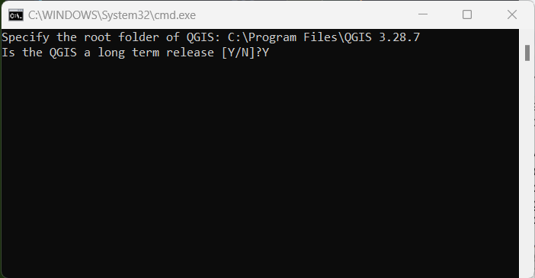

After running this file, answer the associated prompts. The first is identifying the root folder of QGIS as listed in program files. Mine, for example, is C:\Program Files\QGIS 3.24.2. The second is a yes/no question depending on the program’s status, and if it is a long-term release or not. The easiest way to identify this is by opening QGIS and seeing if there is a banner on the splash screen, bottom option in image below.





## Set-Up

The **GALUP_scenario_tool.zip** contains the plugin and the **dataset.zip** has the various shapefiles, rasters, and tables needed to run the simulation. Do not unzip the **GALUP_scenario_tool.zip** folder. Unzip the *dataset.zip* folder.

## Plugin Import

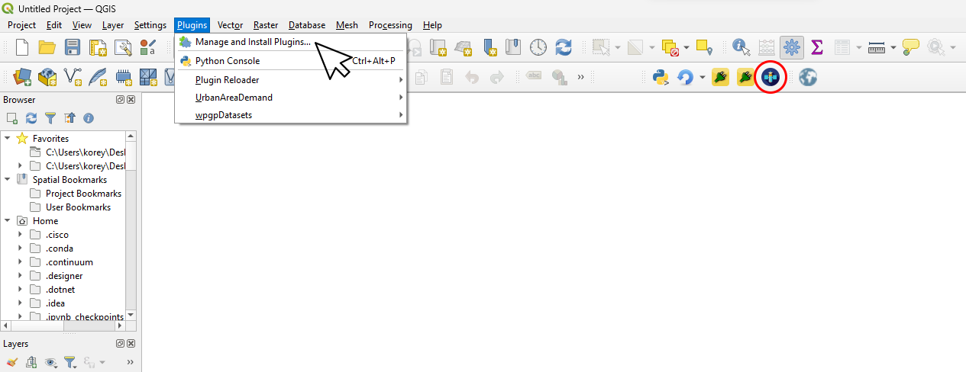

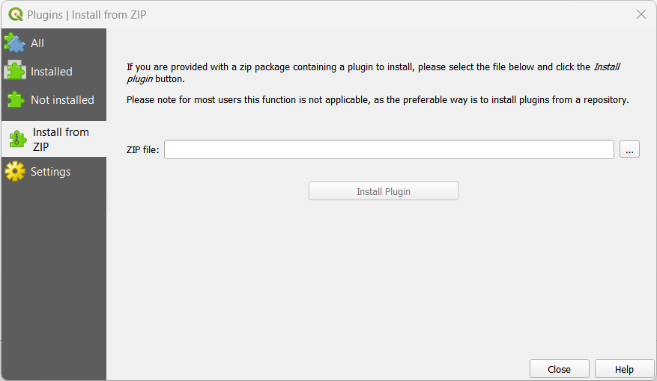

* Open QGIS
* Navigate to the *Plugins* tab
* Click the tab and open the *Manage and Install Plugins* dropdown
* On the left pane of the new window, navigate to *Install from ZIP* tab
* Click the ‘...’ and select the *GALUP_scenario_tool.zip* file from the downloaded directory
* Click *Install Plugin*.
* Wait for a ‘Plugin Installed Successfully’ Pop-Up
* Close the QGIS application and re-open it to force a refresh of the installed plugins
* After this, the satellite icon of the plugin should appear in the toolbar as pictured above (circled in red)
* Click on it to open the interface

# Interface

The interface has 2 distinct modes of operation, each with their own unique data needs. They are:

* Using a custom study area that does not align with one specific geographic (region/district) boundary
* Or analyzing a particular region or district

In this instance, we’re doing the first option and using the data from the folder provided to look at a section of the Kumasi area. Because of this, the parameters must be entered a specific way

**Note:**

The yellow highlight indicates things to be tested for functionality and/or impact on result

The green highlight is the standard/default value for the smoothest operation

## Scenario Configuration

The first tab of the interface (or, GUI) defines the temporal and spatial extents of the simulation while also setting the study area and constraints on density and temperature changes.

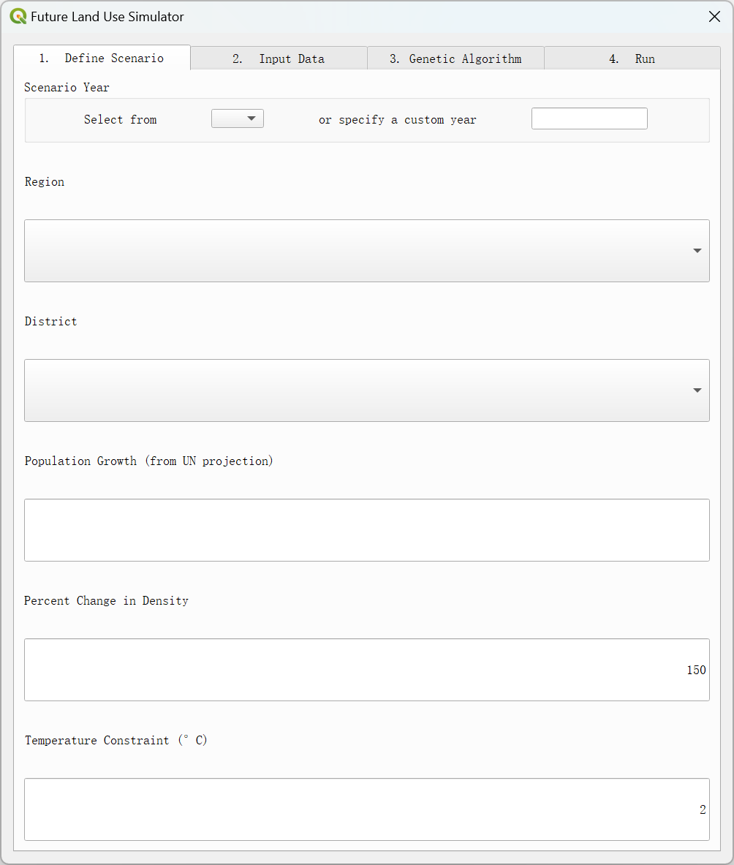

### 1.1. Scenario Year

The scenario year is the desired year the simulation will take place. This information is needed to estimate the population growth and therefore allot the appropriate amount of land to support that quantity of people.

Inputs

* The select dropdown has years 2025-2100 in 5 year increments
* A custom year can also be input by the user
  + If this option is selected, the user must input the projected population

Default

* No default value

Please test functionality of dropdown in tandem the region/district dropdown and see how it impacts expected population value

For this demonstration select the year 2050

### 1.2. Region

This dropdown is for users who want to operate at the region and district level instead of providing their own unique study area. Users with specific study areas should select the N/A option.

Inputs

* Dropdown has every region in Ghana
* N/A can be entered for unique study area

Default

* No default value

Please test functionality of region dropdown and its impact on populating the district dropdown

This field should be set to N/A for this demonstration since a custom study area is used

### 1.3. District

This dropdown has each district for the selected region and also gives the option to select the *entire region* as the study area. Users with their own study area/shapefile should select the N/A option for Region and the District will automatically be empty.

Inputs

* Dropdown has every district in Ghana
* N/A can be entered for unique study area

Default

* No default value

Please test functionality of district dropdown and associated current population autofill

This field should be empty for this demonstration since a custom study area is used

The 4157733 value is the current population for the study area shapefile provided

### 1.4. Projected Population

The projected population is used with the chosen density to determine how many urban pixels are needed. The projection is based on United Nations data. This field auto-fills based on the selected year, region, and district. Users with their own study area shapefile need to input this value themselves.

Inputs

* Auto-Populates for region/district boundary and desired year
* Input necessary for custom study area

Default

* No default value

Test different projected population values to understand implications of population pressure

The 5157733 value represents an anticipated population growth of 1 million people by 2050

### 1.5. Percent Change in Density

This value represents the percent change in people/urban area between the current land use scenario and the future simulation.

Inputs

* Numerical value from 0-200 required for calculating change in land uses

Default

* Defaults to 150% increase

This field should remain at 150% for the optimal scenario

### 1.6. Temperature Constraint

The temperature constraint is the maximum increase in surface temperature allowed by the simulation.

Inputs

* Numerical value from 0-5 required for calculating change in land uses

Default

* 2 degrees celsius

Test different temperature constraints to evaluate impact of this constraint on land cover optimization

This field should remain at 2 degrees for the optimal scenario

## Data Input

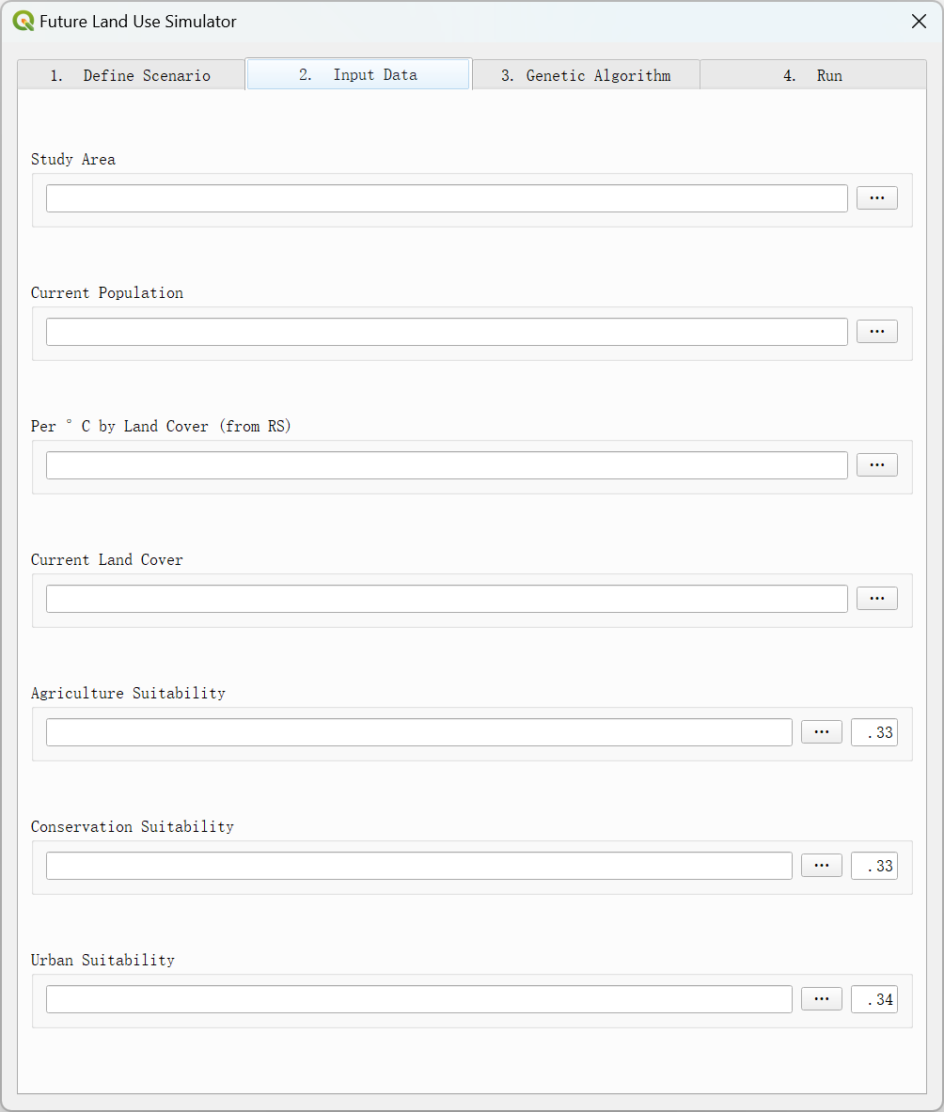

### 2.1. Study Area

The study area is the shapefile or geopackage with the boundary of the unique area for the simulation. This area needs to be rectangular and subdivided into squares that are 250x250 meters.

Inputs

* File path to study area .shp or .gpkg

Default

* No default value

Navigate to the ‘dataset’ folder and select **study_area_kumasi.shp**

### 2.2. Current Population

This parameter is used to understand the current development density that will inform future land use decisions. This field auto-fills when using the region/district presets, but will require custom input if users have their own study area.

Inputs

* Auto-Populates for region/district boundary
* Input necessary for custom study area

Default

* No default value

### 2.3. Per °C by Land Cover (from RS)

This parameter calls on a spreadsheet containing values for how much the temperature increases per additional cell of each land cover type.

Inputs

* File path to slopes .csv

Default

* There is No default value

Navigate to the **dataset** folder and select **temperature_slopes.csv**

### 2.4. Current Land Cover

This parameter is a raster layer of the rescaled land cover types where raster values have the associated land cover 0: "border", 1: "agriculture", 2: "conservation", 3: "urban", 4: "water", 5: "herbaceous".

Inputs

* File path to land cover .tif

Default

* No default value

Navigate to the **dataset** folder and select **land_cover_2019.tif**

### 2.5-2.7. Agricultural, Conservation, and Urban Suitability

These are rasters of the suitability of each cell for the three particular land uses. The numbers adjacent to the file path input parameter are their associated weights. The three weights must equal 1.0.

Inputs

* File path to suitability .tif and weight value =< 1

Default

* The default value for the weights is approximately equal

Navigate to the *dataset* folder and select **suitability_ag.tif**, **suitability_con.tif**, **suitability_urb.tif**. Leave weight values ‘as is’

## Genetic Algorithm

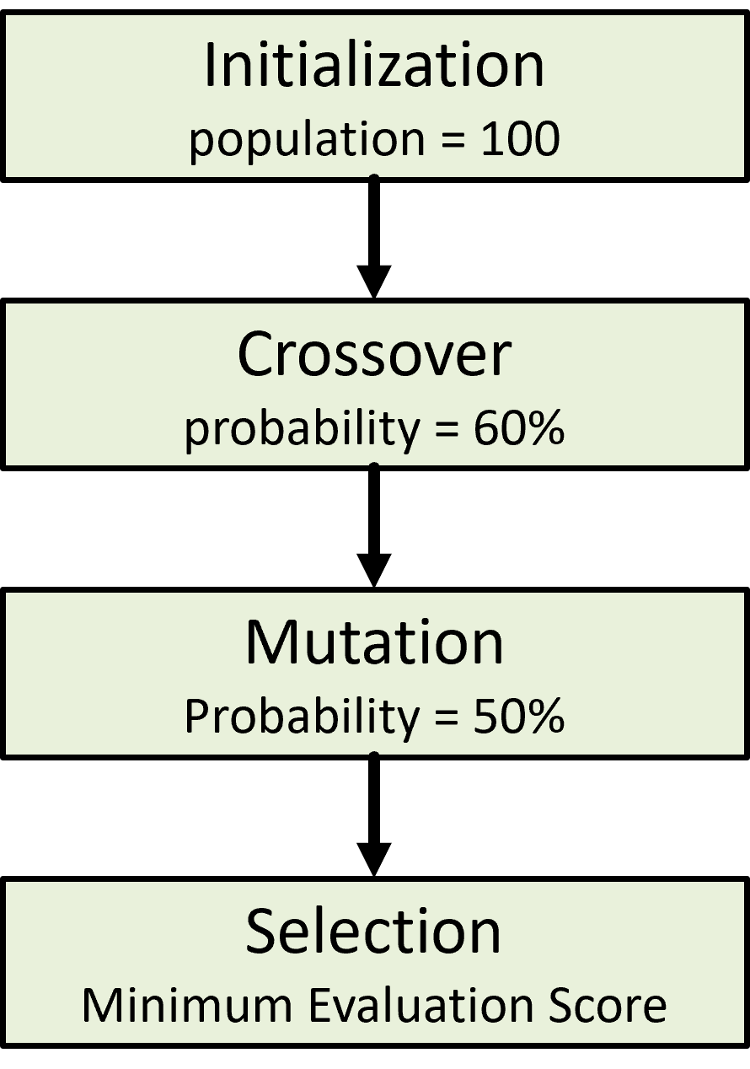

The genetic algorithm (GA) is a method based on the concept of natural selection that is applied to optimization problems. For this purpose, the GA was applied to develop a potential land use scenario with optimized population accommodation and limitation of land surface temperature increases (LST).

* The optimization occurs through selecting the most fit individual scenarios to pass on their characteristics to the next generation of scenarios
* The fitness of a scenario was based on adherence to constraints and objectives and this was quantified through an evaluation score
* The goal of the genetic algorithm was to minimize this score, indicating a high fitness and thus optimal scenario
* One constraint was limiting LST increase to less than 2 °C.
  + The LST constraint utilized remote sensing time series data analysis to calculate the predicted LST changes occurring with the land use changes enacted by the algorithm.
* The other constraint was to allow for population growth of 1,000,000 people, hence the set population values

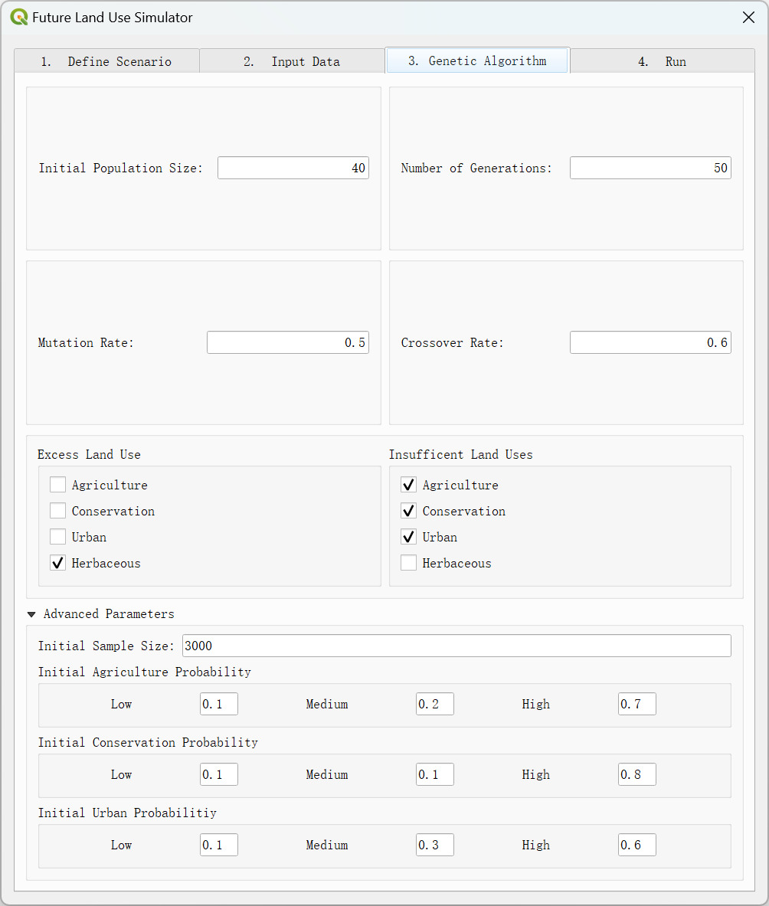

### 3.1. Initial Population Size

The initial population size is the number of individuals that undergo mutation and crossover until an optimal individual is achieved.

Inputs

* Value between 20 and 100

Default

* Defaults to 100 individuals

Using a smaller value such as 20 individuals to test the functionality of the tool in 15-20 minutes. Note that the simulation may not be optimized with this population.

Test the simulation at the full 100 individual starting population overnight/in the background. This process could take up to 4 hours with this value

### 3.2. Number of Generations

Value of how many iterations of the simulation is run from the initial population.

Inputs

* Value between 5 and 100

Default

* The default value is 100

Using a smaller value such as 5 generations to test the functionality of the tool in 15-20 minutes. Note that the simulation may not reach the most optimal scenario in this timeframe.

Run the simulation at the full 100 value overnight/in the background. It could take up to 4 hours for that number of generations

### 3.3. Mutation Rate

This is a variable parameter based on random selection. Mutation is the conversion of one land use type to another and the rate is symbolic of the proportion of the population that undergoes this operation.

Inputs

* Value between .01 and .99

Default

* The default value is 0.5

Test the impact of high and low levels of mutation, try values like .1 and .9

Try the default value of 0.5

### 3.4. Crossover Rate

This is a variable parameter based on random selection. The crossover rate is the percent of the total population that will undergo crossover where a land use type will swap between two individuals during the simulation.

Inputs

* Value between .01 and .99

Default

* The default value is 0.6.

Test the impact of high and low levels of crossover, try values like .1 and .9

Try the default value of 0.6

### 3.5. Excess Land Uses

Herbaceous land is assumed to be in excess, individuals in the simulation will actively shift away from this land use first.

Inputs

* Check or unchecked boxes

Default

* Unchecked by default

This parameter’s functionality is currently limited

Leave unchecked for this simulation

### 3.6. Insufficient Land Uses

To have some sort of change in the simulation, the equilibrium of the scenario has to be off. Here, the agricultural, urban, and conservation land are presented as insufficient.

Inputs

* Check or unchecked boxes

Default

* Unchecked by default

This parameter’s functionality is currently limited

Leave unchecked for this simulation



### 3.7. Initial Sample Size

In the initial population, diversity of individuals will be implemented to improve GA efficiency. This diversity is accomplished through prioritizing agriculture, conservation, or urban land uses by changing pixels within respective individuals to the prioritized land use. The initial sample size represents the number of pixels within an individual that will be assigned to the prioritized land use.

Inputs

* Value between 1000 and 3000

Default

* The default value is 3000

The fields should remain at 3000 for the optimal scenario

### 3.8. Initial Probabilities

During the diversification of the initial population, the probabilities dictate how the prioritized land use will be allocated throughout the individual. Out of the sample size number of pixels to be changed, the low probability represents the percent of pixels that will have low suitability for the prioritized land use, the medium probability is the percent of pixels with medium suitability, and the high probability is the percent of pixels with high suitability. For example, for agriculture, 10% of pixels changed will have low levels of agricultural suitability, 20% have medium suitability, and 70% are highly suitable for agriculture uses.

Inputs

* 3 values for each row that total 1

Default

* The default values are displayed in the image

The fields should remain ‘as is’ for the optimal scenario

## Output File

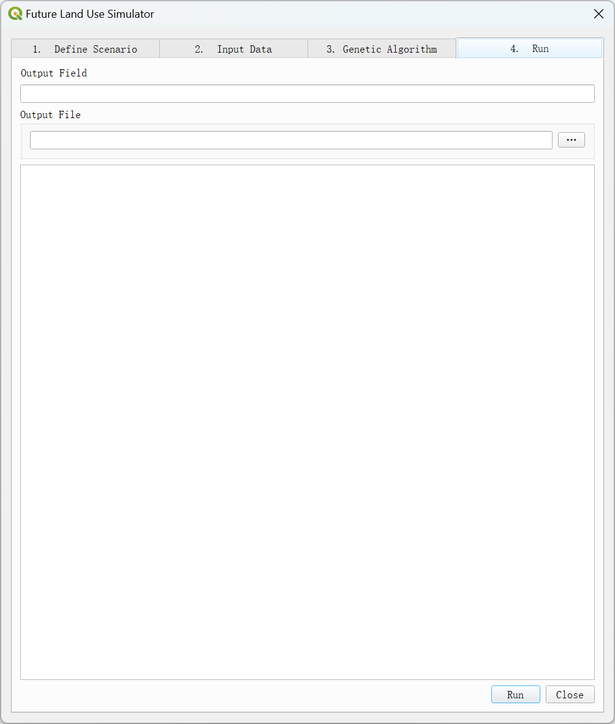

### 4.1. Output Field

The name of the new output field from the genetic algorithm.

Inputs

* Text name for new field

Default

* No default value

Select any name for the final field

### 4.2. Output File Path

Setting the path and name of the output shapefile.

Inputs

* Select the output file path and set the output shapefile name

Default

* No default value

Enter any path and file name with the end of .shp

# Results

The final output is a bounding box around the Kumasi study area, and should be automatically added to the QGIS project.

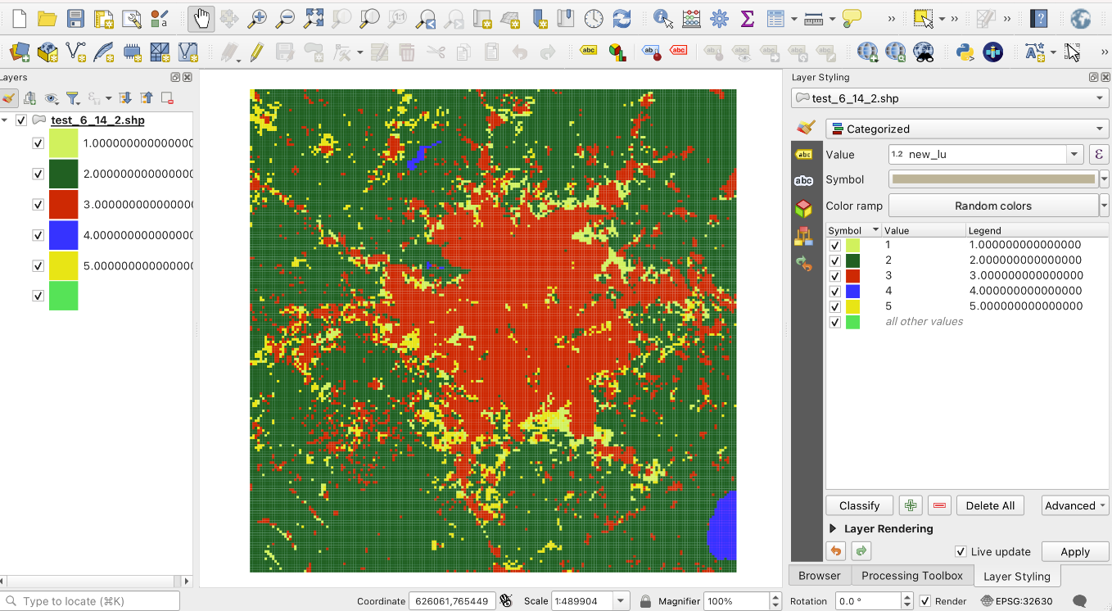

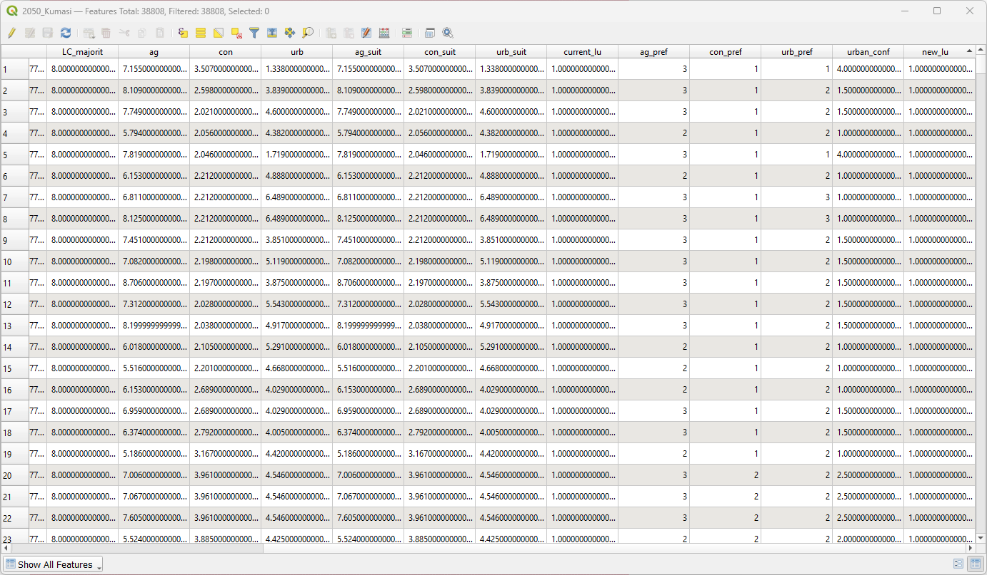

This box is divided into 250x250m square cells, each with their own unique land cover value. The output example has the file name 2050_Kumasi (entered into the GUI), and the output field from the GA was called new_lu (also entered into the GUI). The results of this scenario testing can be evaluated by symbolizing the current_lu and the new_lu classes and comparing them.